Grade Journey for eLearn Ultra (Gradebook)
- For the teaching course site
Step 2: Configure Predefined Grade Column


This guide explores on how to configure the predefined grade columns in eLearn Ultra Gradebook and how to configure the total CA or total coursework grade column.

Part 1: Configure Predefined Grade Columns
Navigate to the Gradebook section and click on Grades to view the grades.
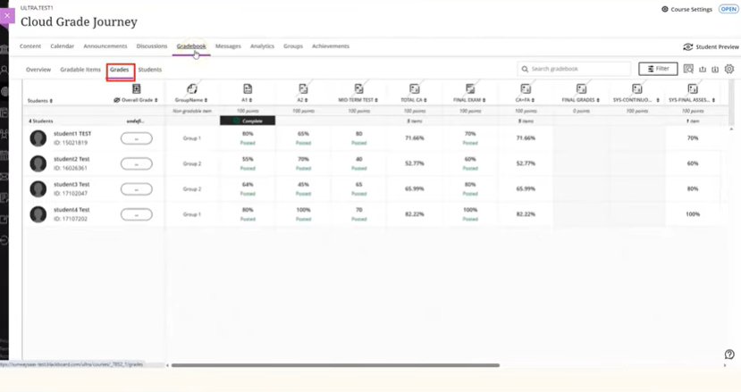

You will see four predefined columns automatically created for your new course site. These columns are set to be hidden from students by default.
Note: Do not show these predefined columns to students.
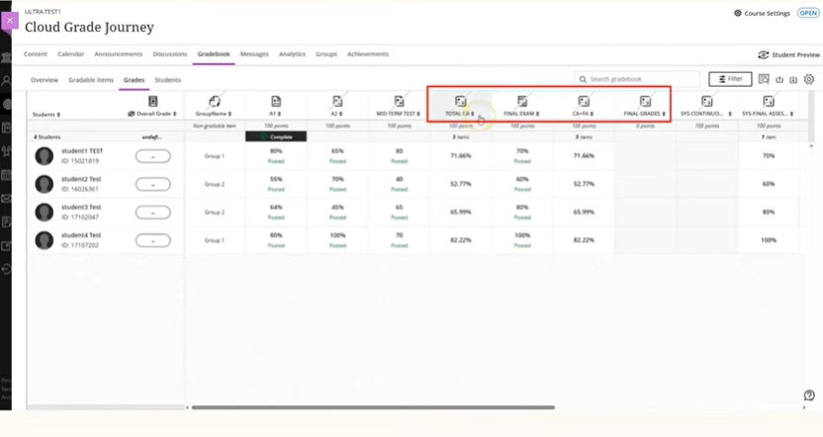
To rearrange the grade column, click on the Gradable Items link.
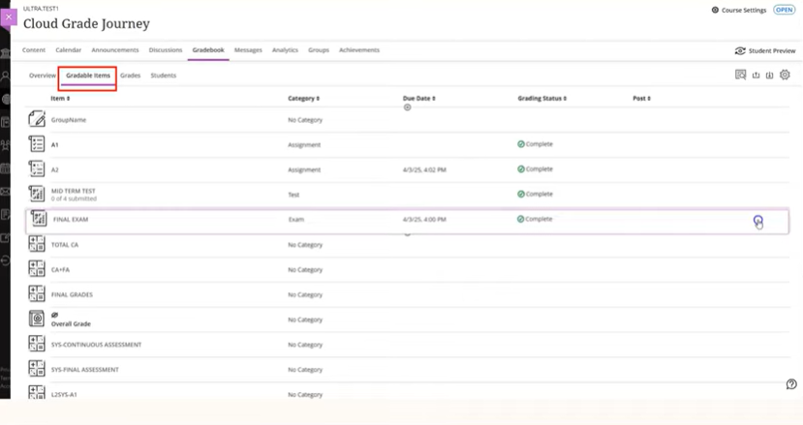

Drag and drop the columns using the arrow icon to rearrange them in your preferred order.
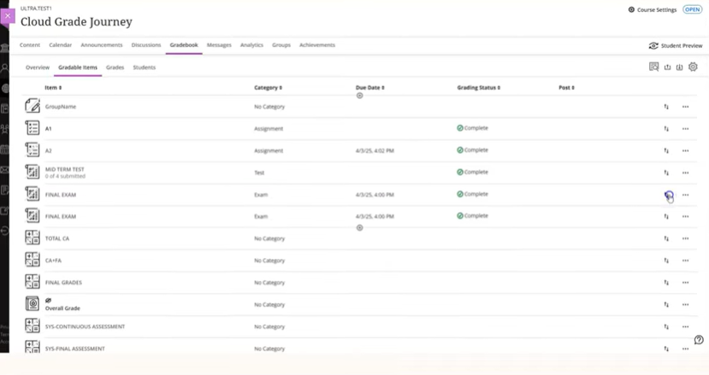

Part 2: Configure Continuous Assessment/ Coursework Grade Column
Let's configure the total CA weighted column. Click on the column header and click Edit.
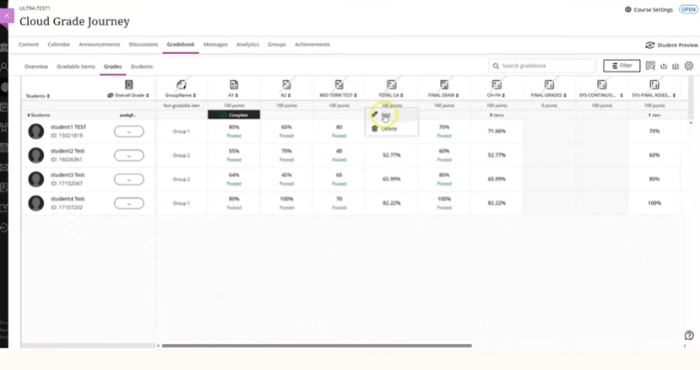
By default, the calculation type is set to weighted type with a proportionally weight gradeable items within a category. Total weightage must be 100% and show in percentage.
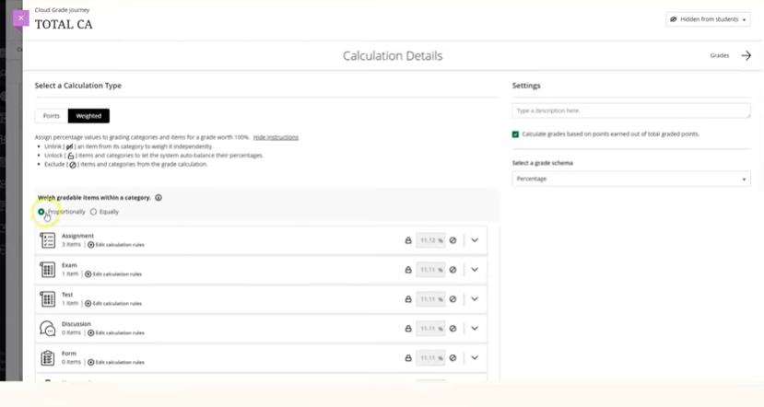

This example shows three components, 40% each for two assignments, A1 and A2 and 60% midterm test that contribute to the total assessment or coursework.
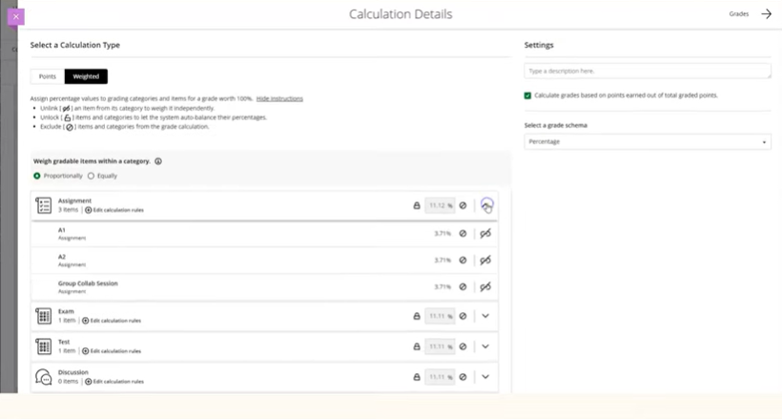
Firstly, click on the exclude icon to exclude items and categories from the grade calculation.
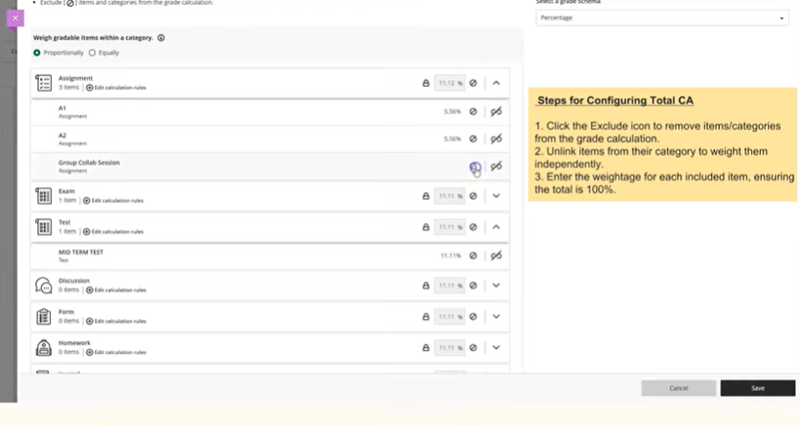
System will auto proportion the weight for remaining items and categories for those are included.

In this example, there are total four assessments created in this course. Three assignments and one test. However, we need to include two assignments, A1 and A2 and one midterm test for the total coursework.
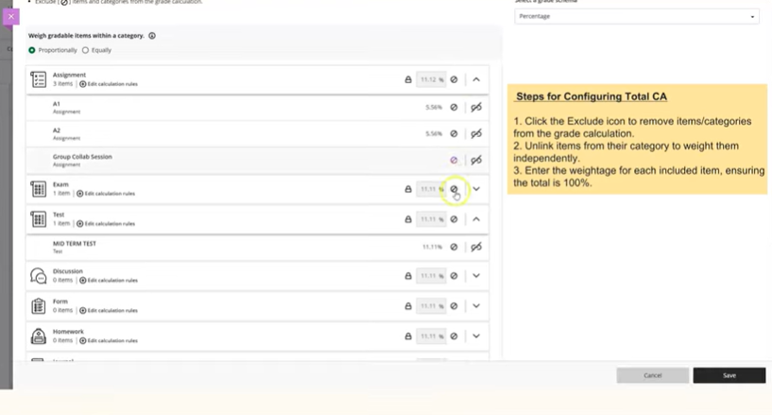
In order to weight them independently, it is required to unlink the item from its category. Make sure to exclude the rest of the gradeable items or category.
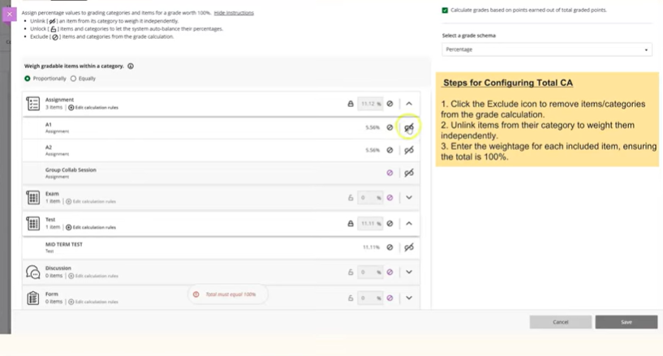

Once unlink it, you can now enter the weightage accordingly for each gradeable items that contribute to your total coursework.
View: Before
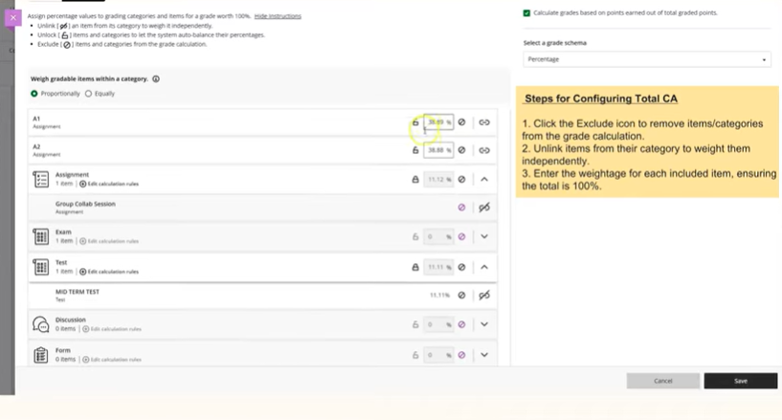
View: After
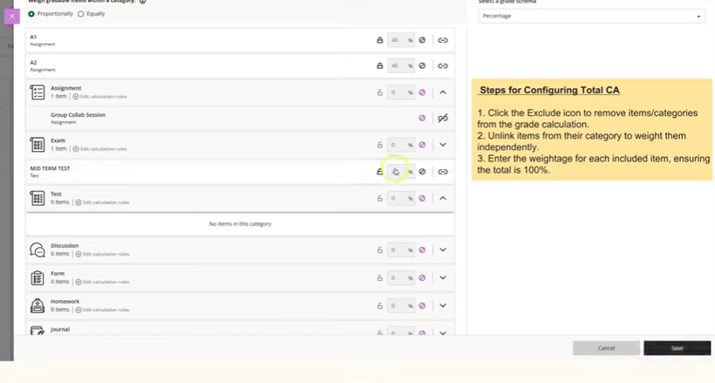

System will only allow you to save if the total weightage is added up to 100%. Click Save.
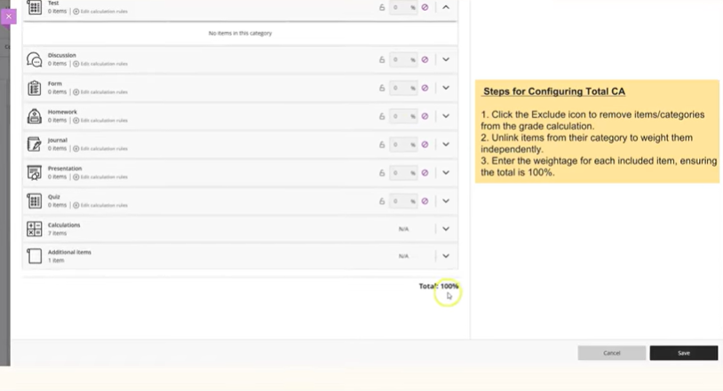

Part 3: Configure Continuous Assessment plus Final Assessment and Coursework and Final Examination (CA+FA, CW+FE) Grade Columns
Let's configure the Continuous Assessment, CA and Final Assessment, FA (CA + FA) or Coursework, CW and Final Examination (FE) (CW + FE) grade column.

Navigate to the CA + FA grade column header and click Edit.
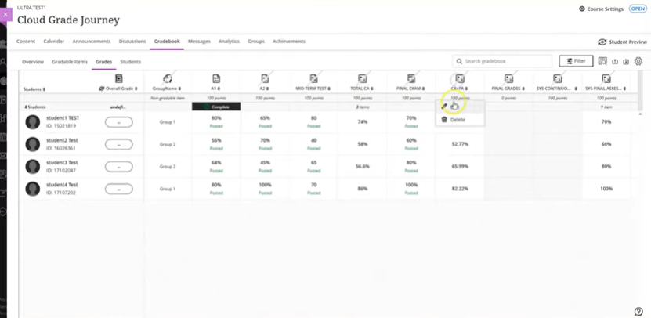
Ensure the calculation method is set to weighted and the display format is percentage.
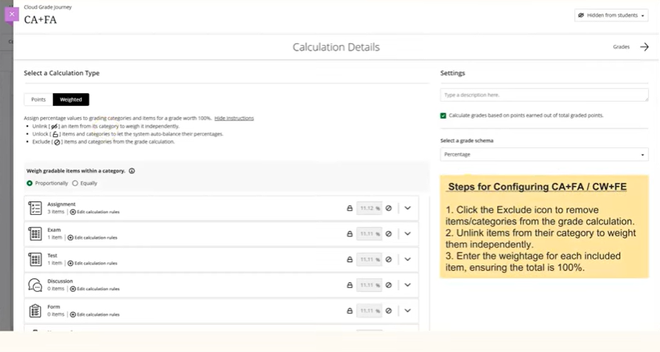

For the CA + FA grade calculation, map it to the total continuous assessment CA and final assessment FA grade columns.
Exclude any gradeable items and categories from the grade calculation.
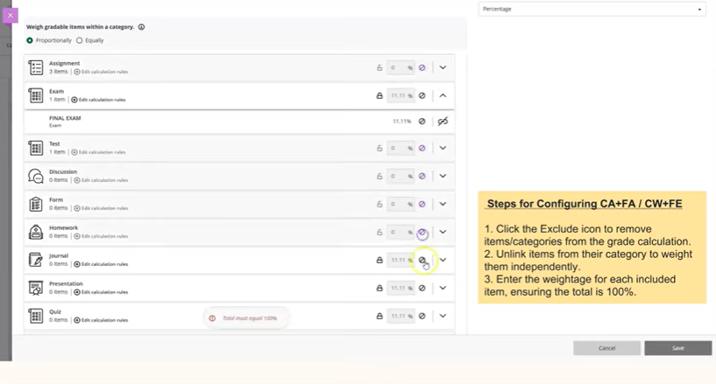
Unlink the total CA and final assessment from their categories to weight them independently.
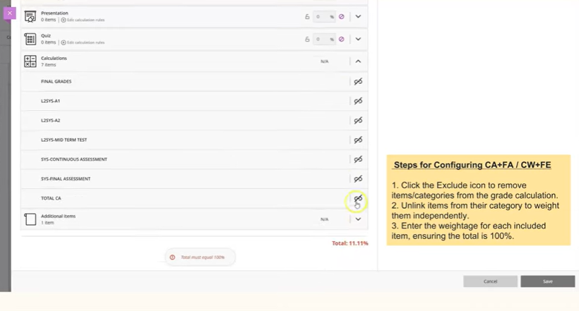

In this example, the weighting is 50% continuous assessment and 50% final assessment.
Total CA, 50%
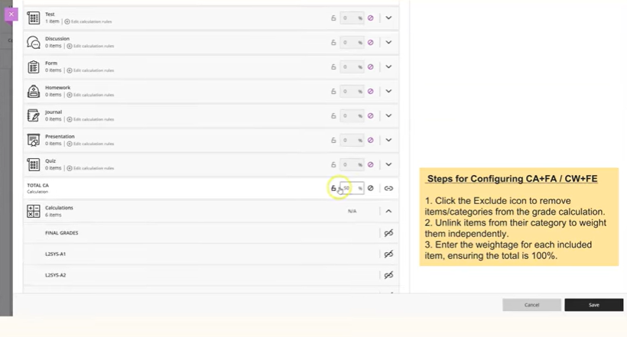
Total FA, 50%
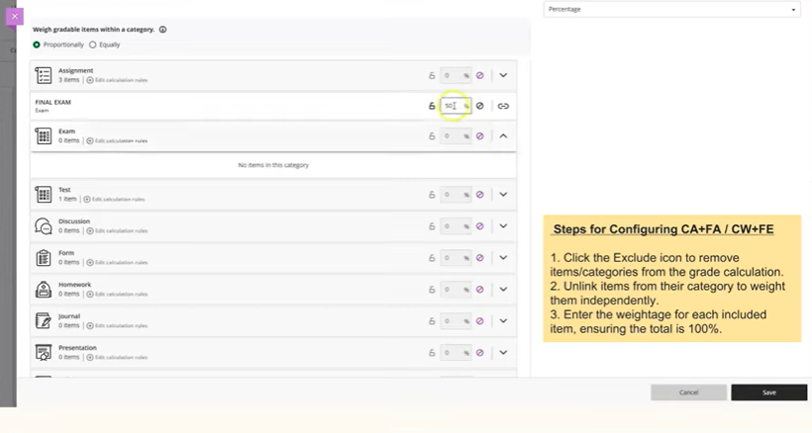
If the final assessment is conducted online using eLearn, map to that grade column accordingly. Once configured, click Save.

View: Before
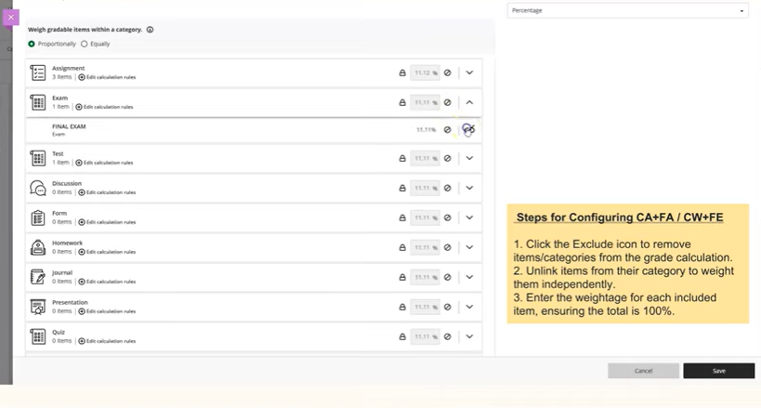
View: After
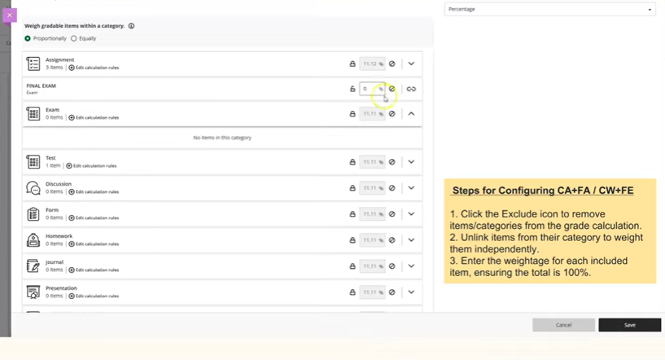

Here’s the final view of CA + FA or CW + FE grade column are configured.
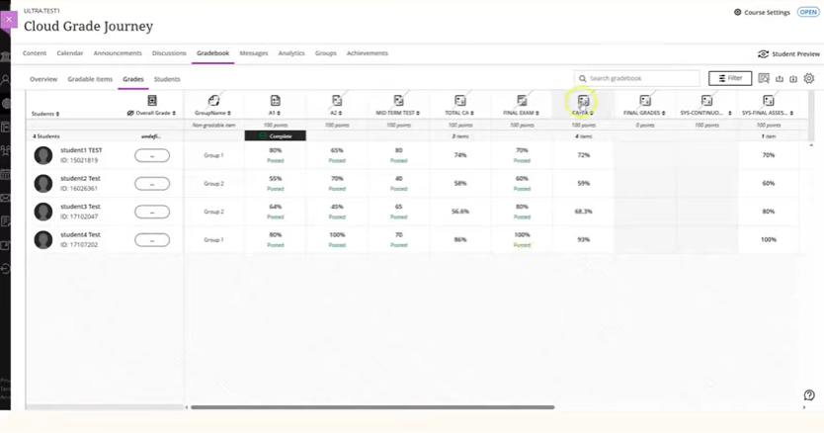

Part 4: Configure The Final Grade or Overall Grade Column
Let’s continue to find out on how to configure the final grade or overall grade column.
Navigate to the Final Grade column header and click Edit.
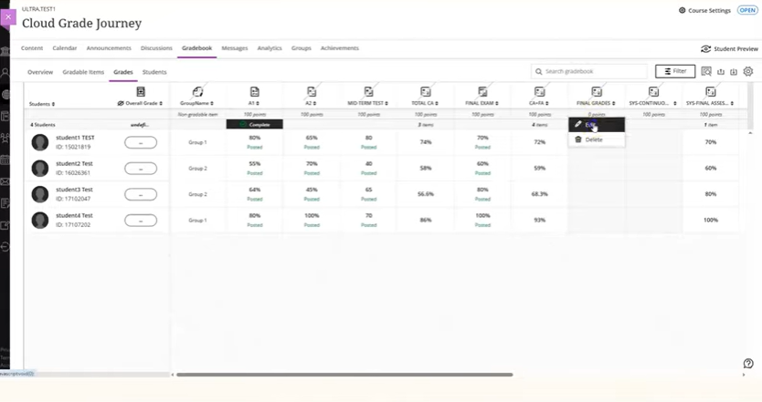
The final grade is set to the default grading scheme used by your department or school, for example CGPA grading scheme.
You may change the grading scheme that used by your course, for example CGPA postgraduate grading scheme, if need to. Then, map the final grade to the CA + FA or CW + FE grade column.

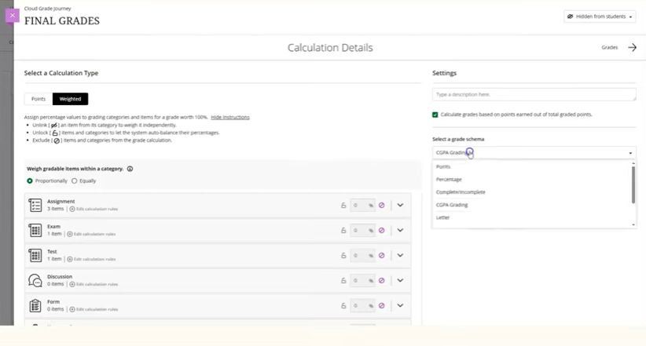
By default, unwanted gradeable items and categories are excluded from the grade calculation and hidden from student view.
Note: Please ensure the final grade column is hidden from student view as the grades have not gone through moderation.
Unlink the CA + FA gradeable item from the calculation category by clicking on the unlink icon. Then, set the weight to 100%.
View: Before
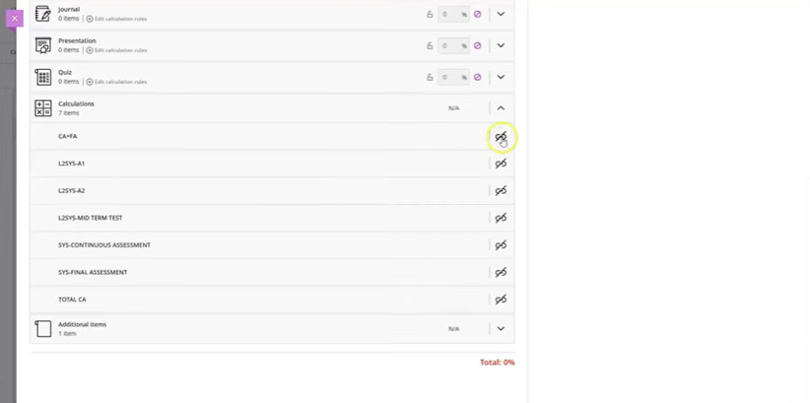
View: After
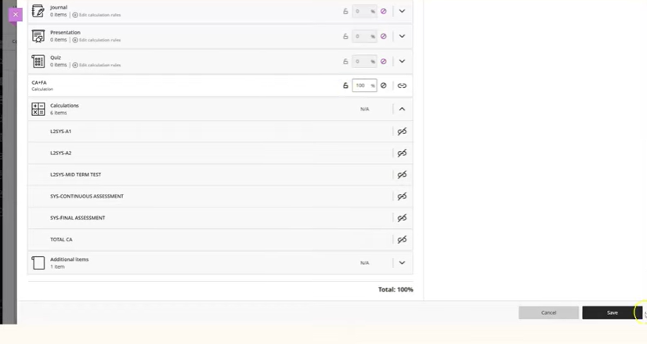
The final grade column will display the grade once the CA + FA grade column is configured. Follow the same step to configure the overall grade column. Click Save.

Here’s the final view of CA plus FA grade column once configured.
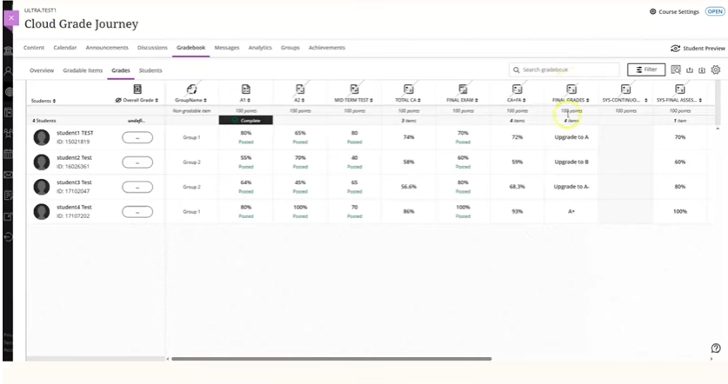

End of Guide

